Wireframe

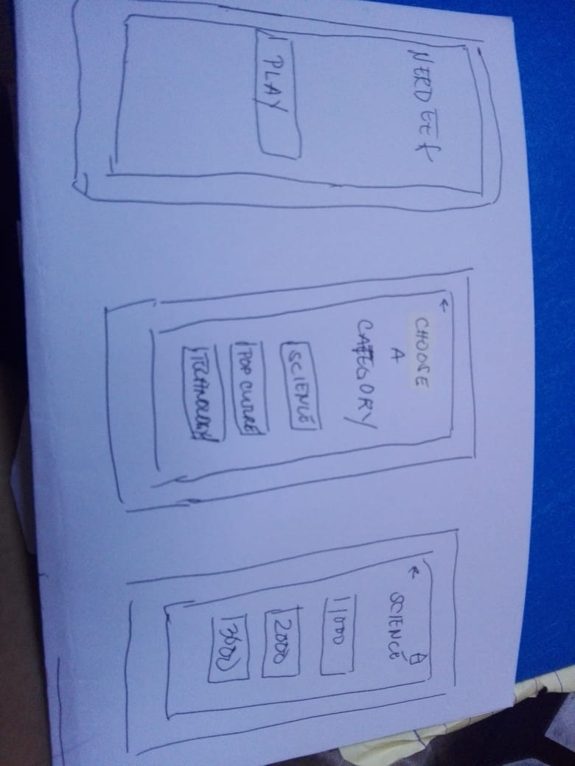 

Category Screen

Title Screen

 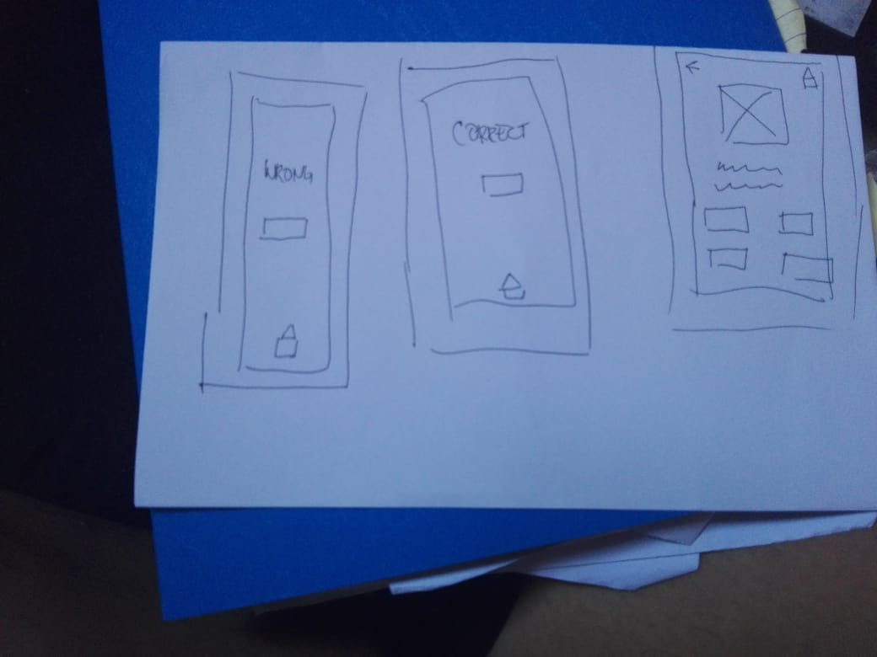

Sample question screen

Question select screen



Right or wrong screen

Mockup

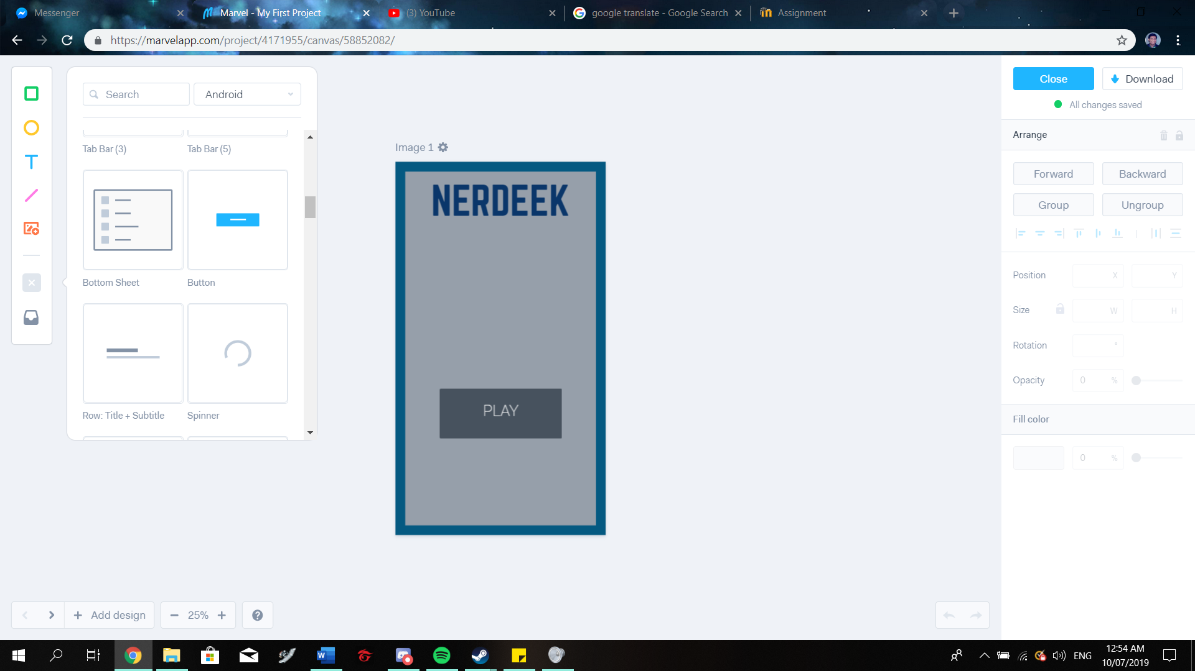 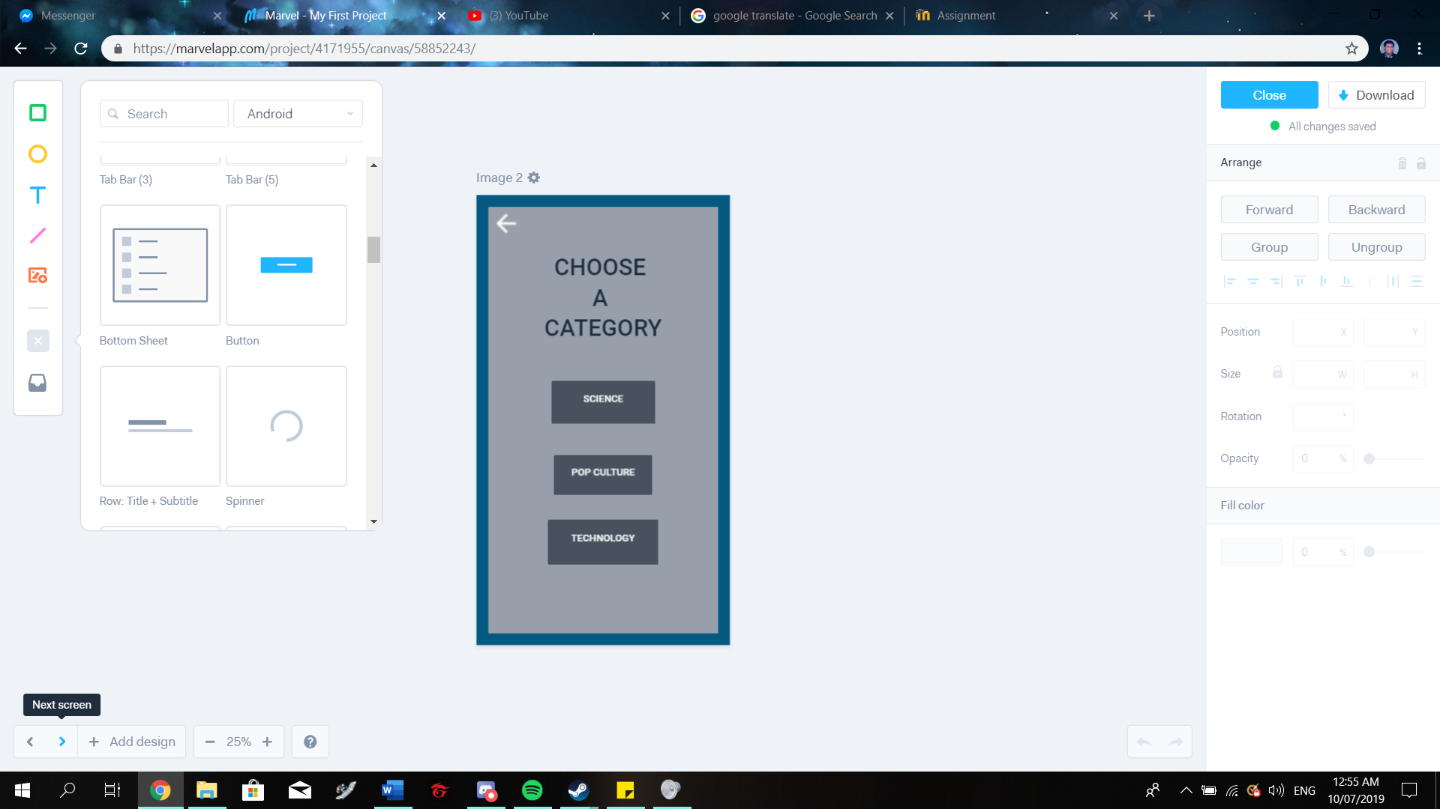

This is the category screen. The user can choose the category of his/her choice. The user can also return to the title screen by selecting the back button.

This is the Title screen. The user will be directed here upon launch

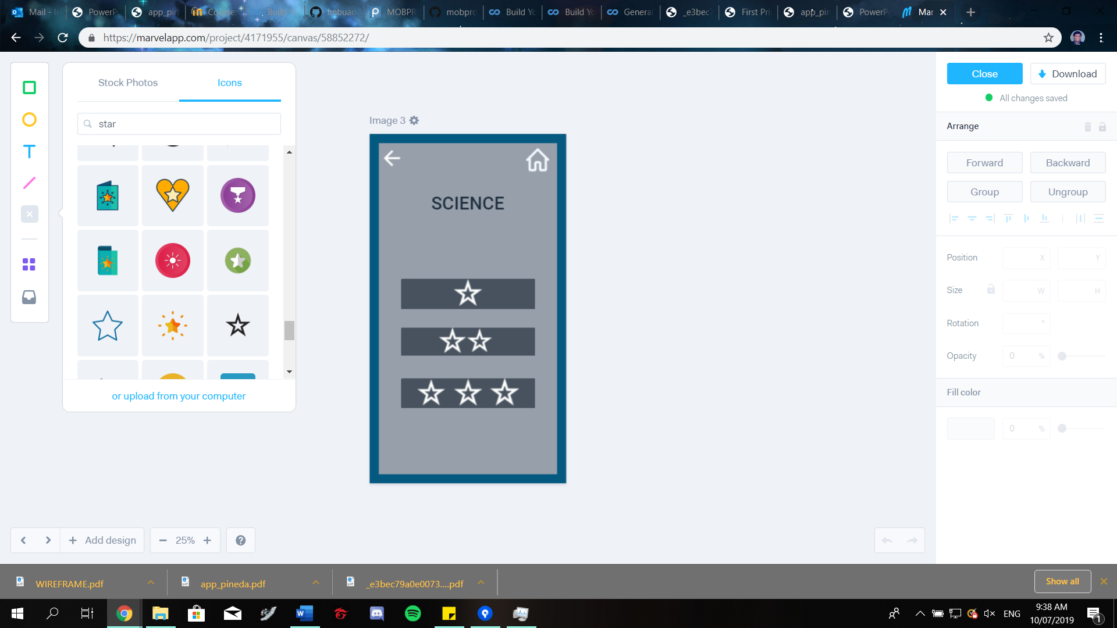 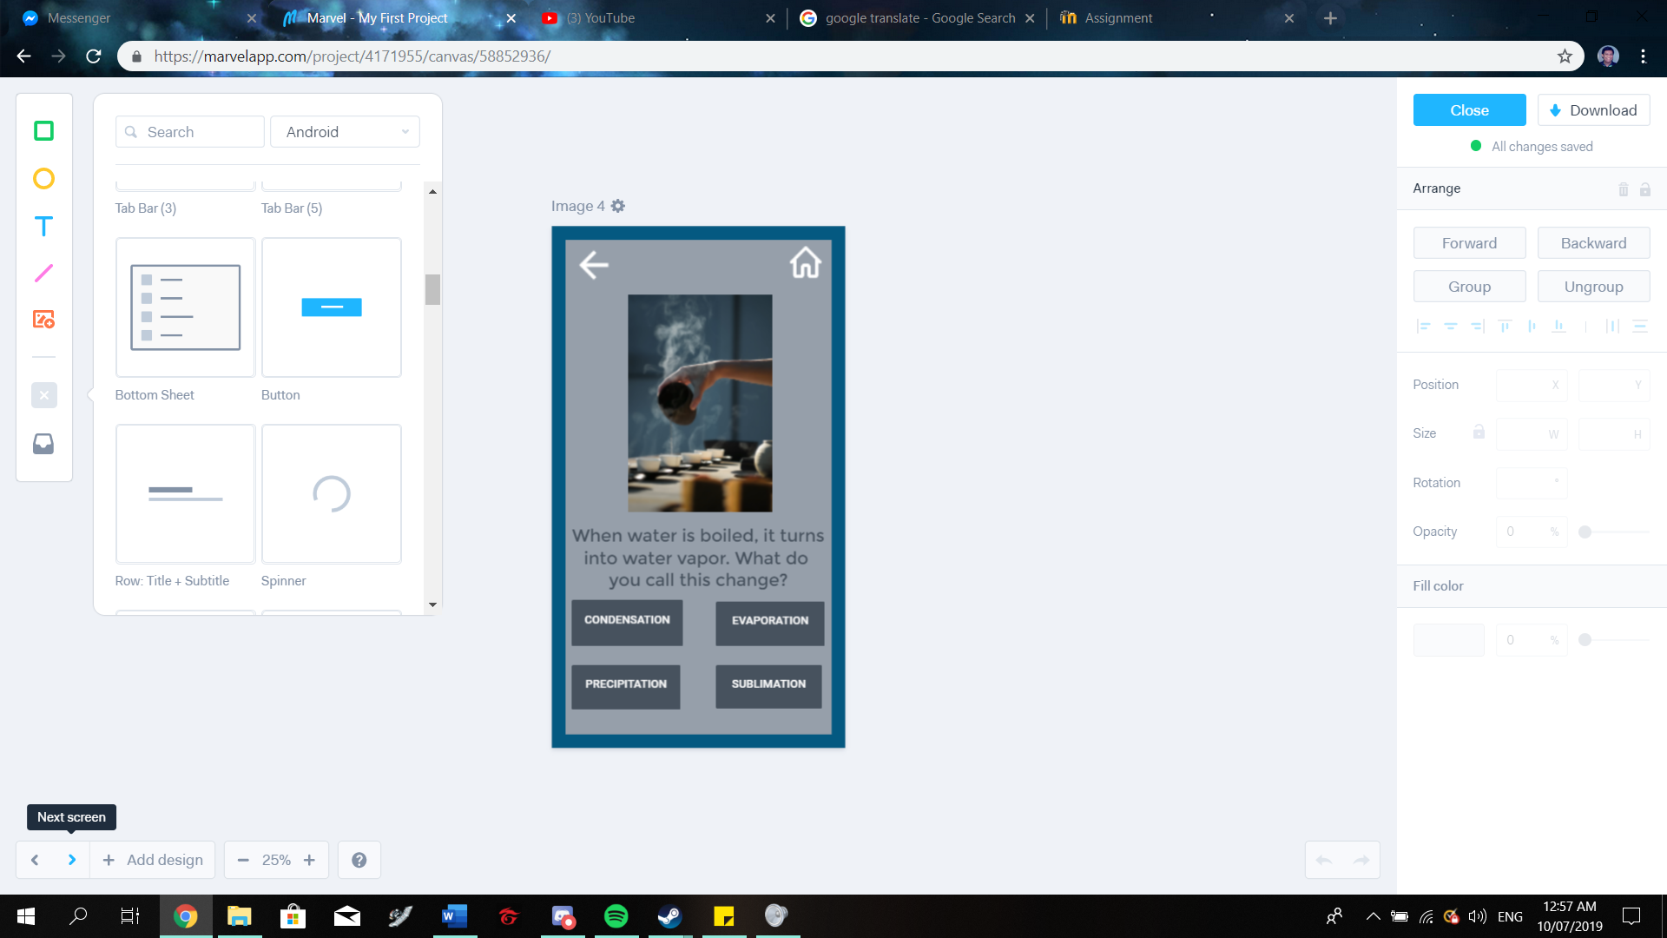

Upon choosing a category, the user can choose the question to be answered. Difficulty of the question will be based on the number of stars (max 3), the more stars, the higher the difficulty.

A sample question.

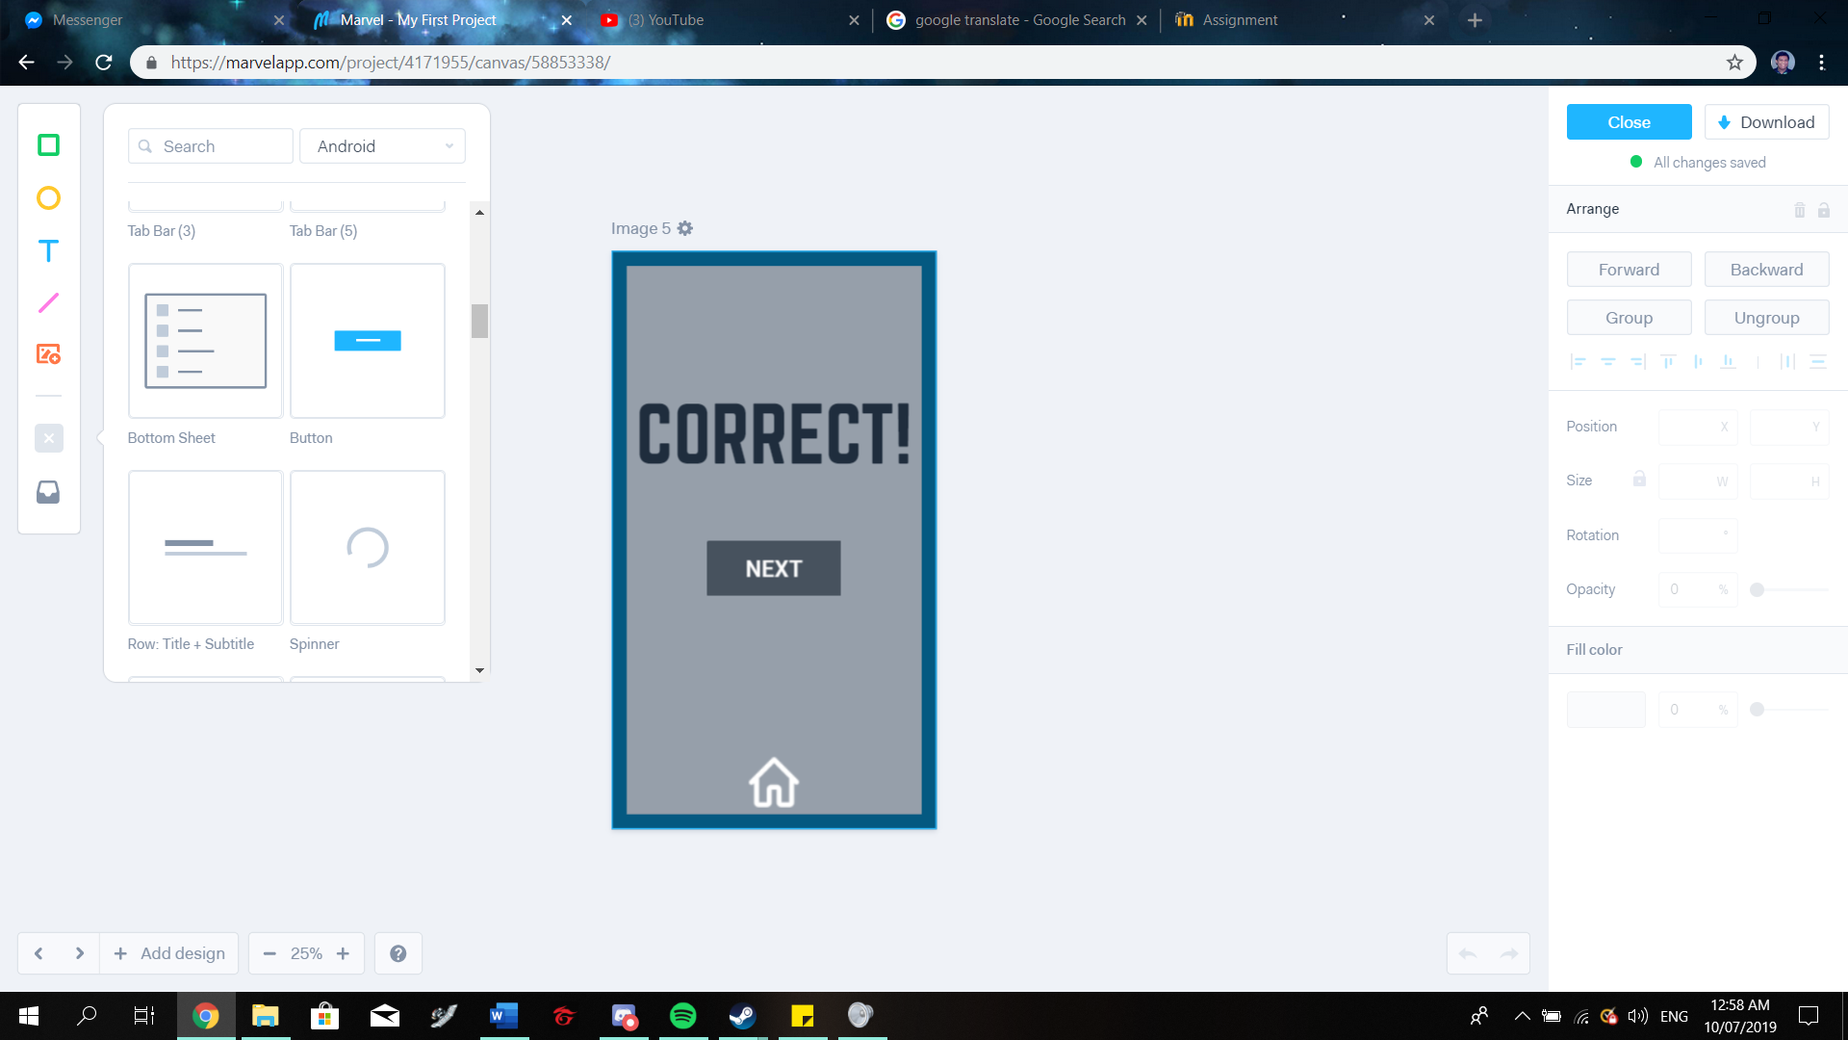 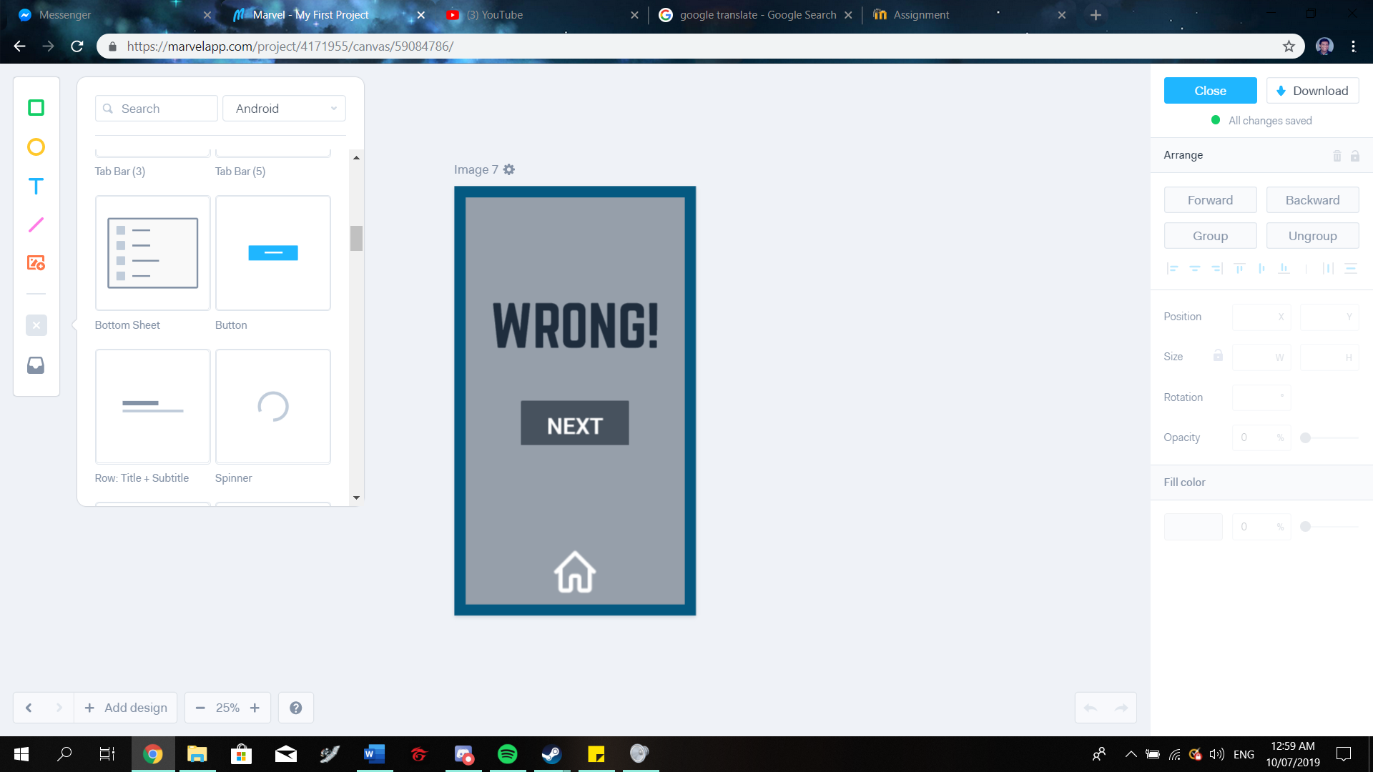

The result screens. If the user answers correctly, the correct screen will appear, if not, then the wrong screen will play out. Both screens have a ‘next’ button that will return to the question selection screen. Both screens also have a home button if the user wishes to return to title screen

Prototype

Link: <https://marvelapp.com/76g0e13>

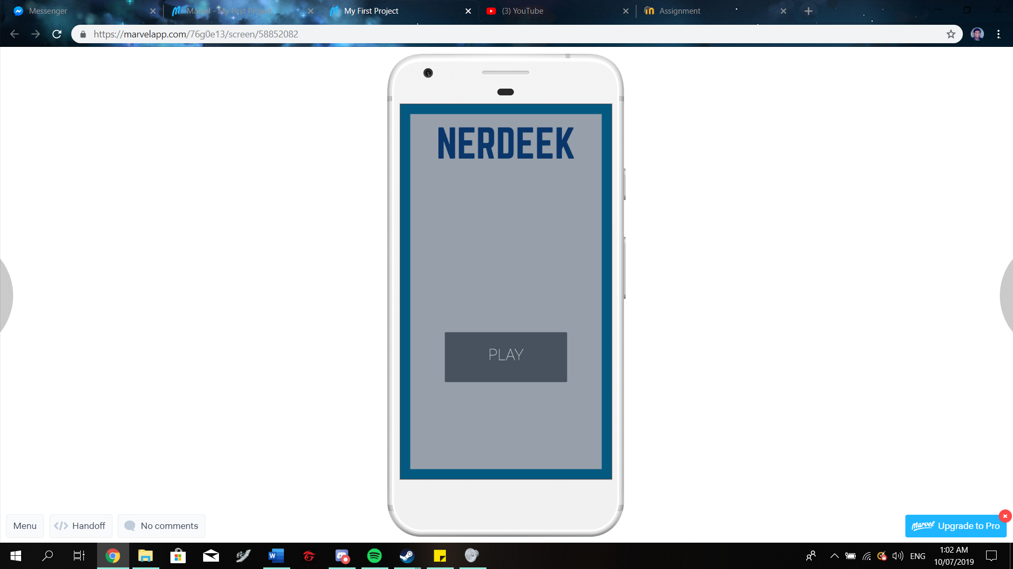 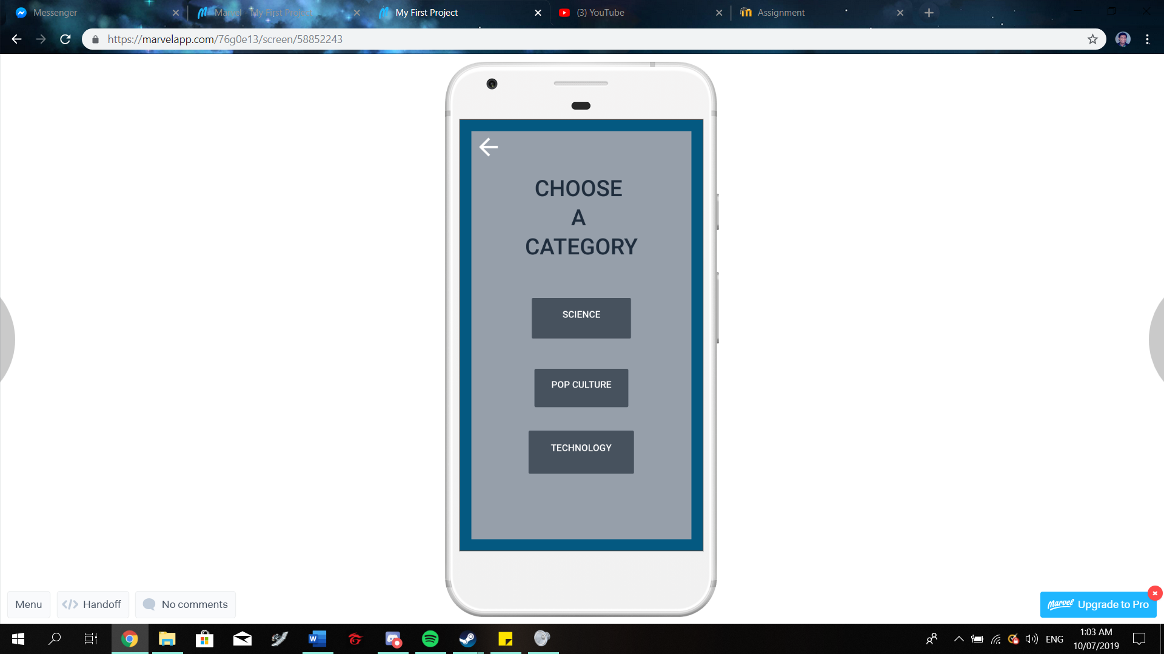

This is the Title screen. The user will be directed here upon launch

This is the category screen. The user can choose the category of his/her choice. The user can also return to the title screen by selecting the back button.

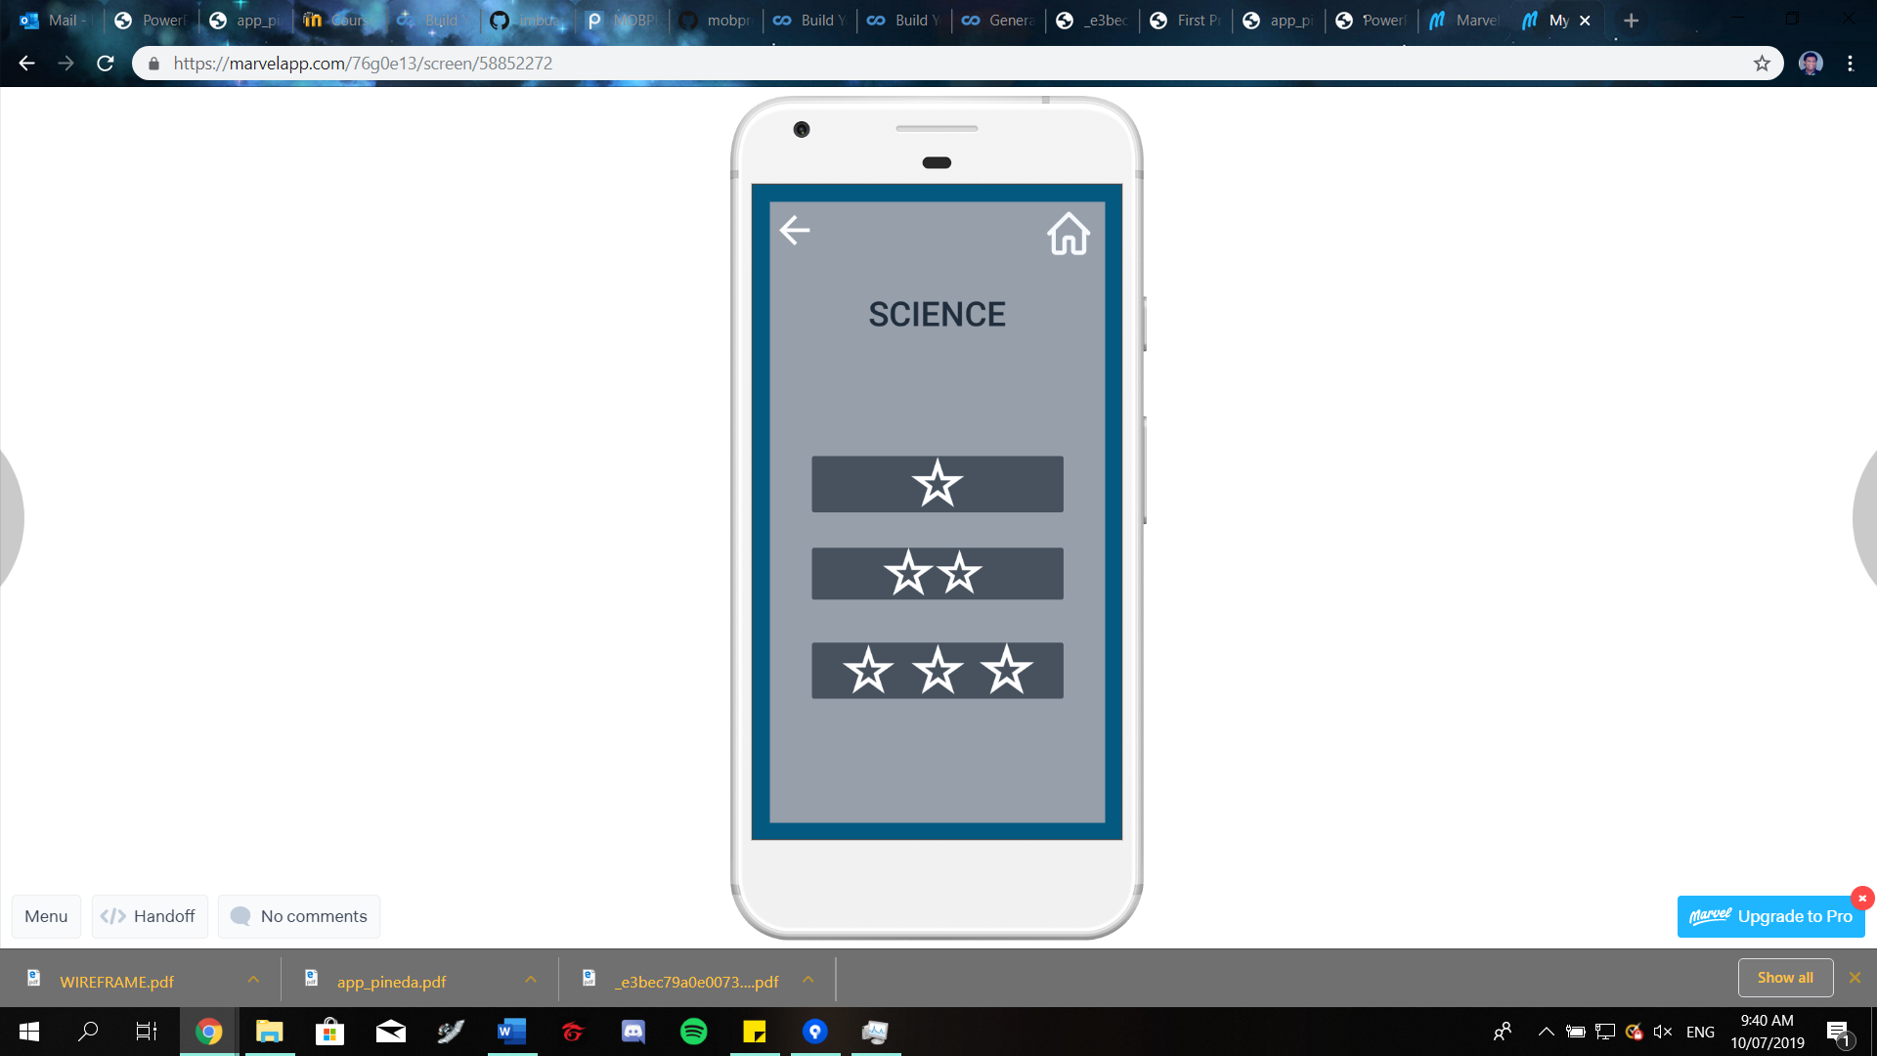 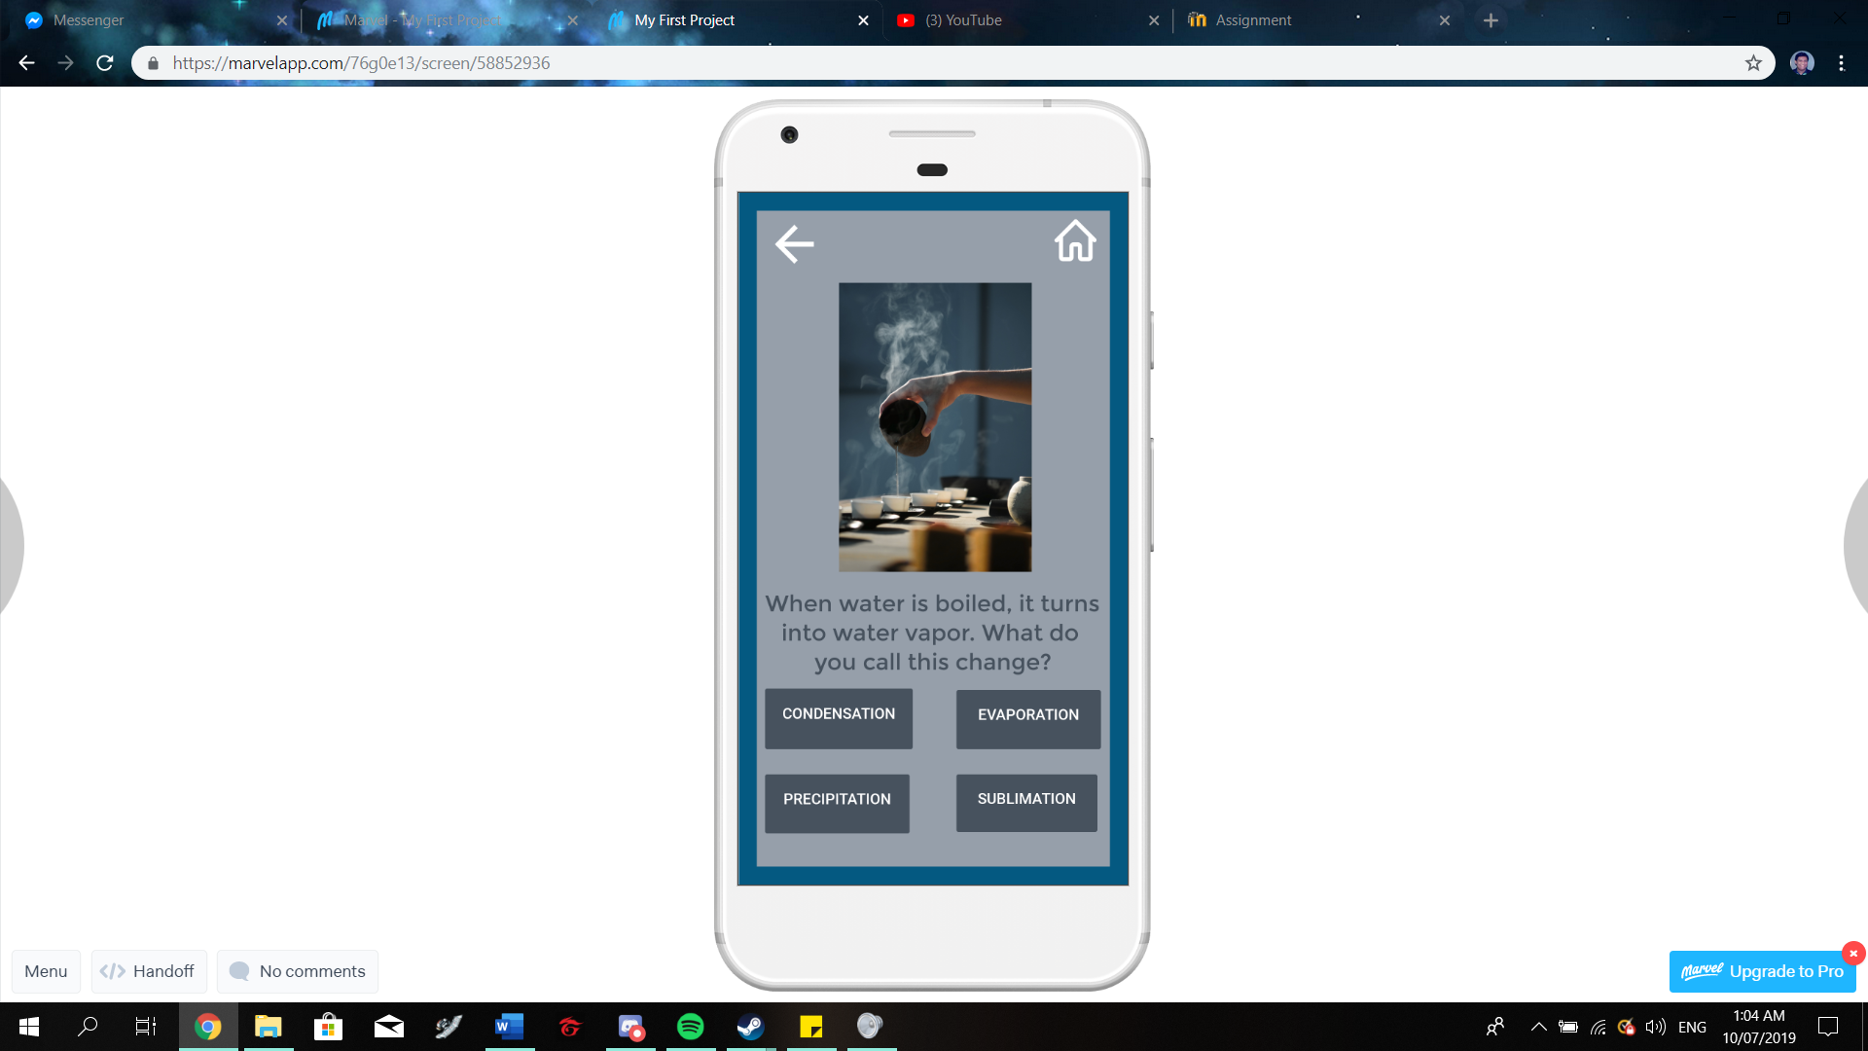

Upon choosing a category, the user can choose the question to be answered. Difficulty of the question will be based on the number of stars (max 3), the more stars, the higher the difficulty.

A sample question.

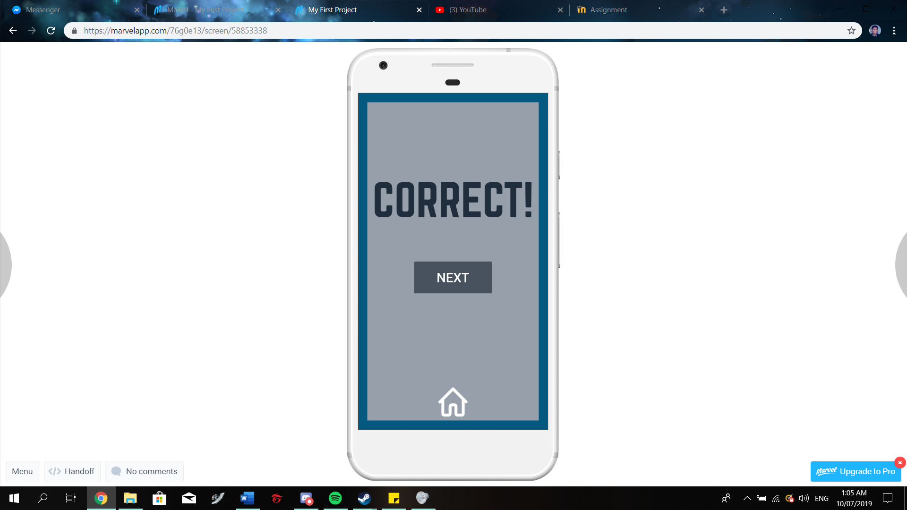 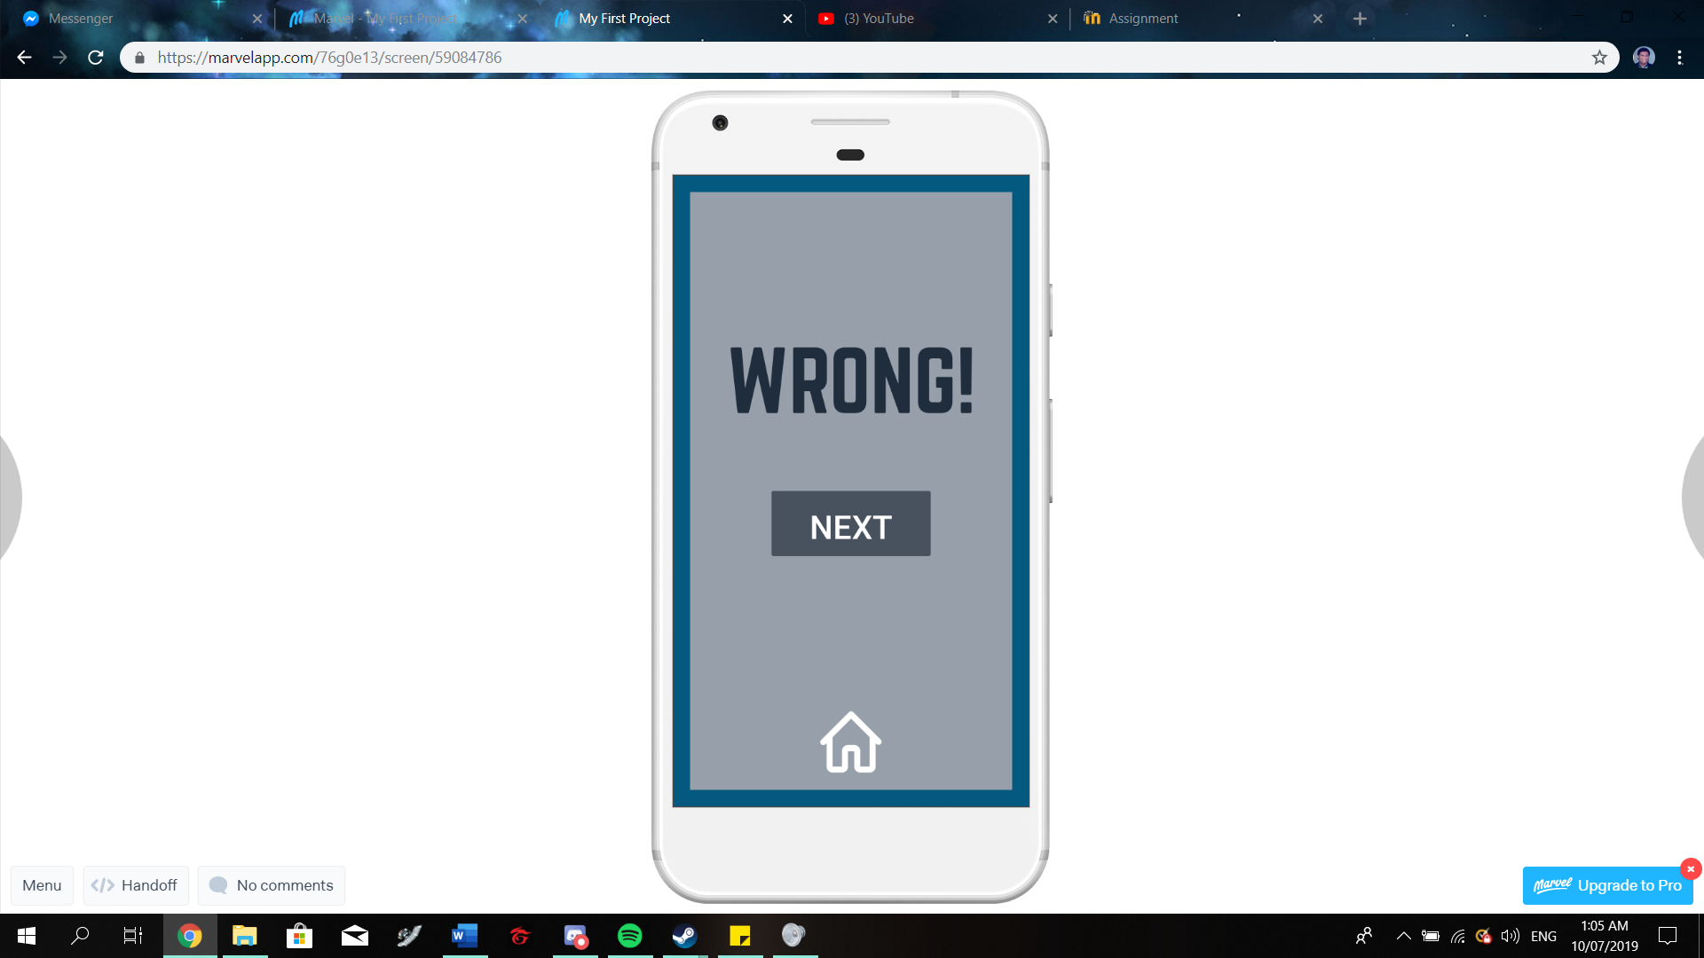

The result screens. If the user answers correctly, the correct screen will appear, if not, then the wrong screen will play out. Both screens have a ‘next’ button that will return to the question selection screen. Both screens also have a home button if the user wishes to return to title screen

App title: Nerdeek

Purpose: test your knowledge…or your luck, by choosing the right answer from a series of questions.

Objectives: Answer all questions correctly.